Findings Chapter

Overview
This chapter presents findings from a cross-sectional study of adult employees examining how job autonomy and supervisor support relate to work engagement, and whether mean engagement differs between hybrid and onsite work arrangements. The analytic approach began with an exploratory examination of the questionnaire's internal structure, including suitability diagnostics, assessment of the number of underlying factors, and oblique rotation, followed by reliability analysis and composite scoring derived from these preliminary measurement checks. Descriptive statistics and a correlation matrix for the resulting scales are reported to characterize the sample and the relationships among the measured constructs. Three hypotheses were then evaluated: a correlation between autonomy and engagement, a multiple linear regression in which engagement is modeled jointly from supervisor support and autonomy relative to an intercept-only baseline, and a comparison of mean engagement between hybrid and onsite employees using an approach that accounts for the possibility of unequal variances and that reports a corresponding effect size. Regression diagnostics, including residual behavior, error variance, collinearity, and the influence of individual observations, were considered as part of this evaluation. An additional analysis extending the regression model to include work arrangement and tenure group was conducted separately from the three hypotheses, as a sensitivity check on the robustness of the autonomy–support–engagement association to background adjustment. Given that the three hypotheses were treated as a family, results are reported alongside Holm-adjusted p values to contextualize the overall pattern of findings. As the design is observational and the work arrangement groups were not randomly assigned, the results that follow should be interpreted as describing associations and group differences rather than causal effects, and the measurement structure identified here reflects a single-sample exploratory analysis rather than an externally validated instrument. The sections below present each result in turn, beginning with the measurement structure and reliability of the scales before turning to the three hypotheses and the supplementary sensitivity analysis.

Interpretation Limits
- Because the design is not a controlled experiment, these results describe relationships and associations, not cause and effect.
- Because the sample was not drawn by probability sampling, generalization beyond this sample should be made with caution.

Descriptive Statistics
sample: N = 360 participants.
Table 1
Sociodemographic Characteristics of the Participants (N = 360)
Variable | n | %
Work arrangement
Hybrid | 185 | 51.4
Onsite | 175 | 48.6
Tenure with the employer
Two to five years | 143 | 39.7
Under two years | 122 | 33.9
Over five years | 95 | 26.4
Table 2
Descriptive Statistics of the Research Variables (N = 360)
Variable | Scale | Min | Max | M | SD
Job autonomy | 1–5 | 1 | 4.80 | 2.96 | 0.82
Supervisor support | 1–5 | 1 | 4.80 | 3.02 | 0.80
Work engagement | 1–5 | 1 | 5 | 3.16 | 0.82
Note. Scale = the response range of the questionnaire items.
Table 3
Pearson Correlations Among the Research Scales (N = 360)
Variable | 1 | 2 | 3
1. Job autonomy | —
2. Supervisor support | .18** | —
3. Work engagement | .37** | .44** | —
Note. * p < .05. ** p < .01. Two-tailed tests.
Table 4
Internal Consistency Reliability (Cronbach's α) of the Research Scales
Scale | Items | Reverse-scored | Removed | Cronbach's α
Job autonomy | 5 | — | — | .84
Supervisor support | 5 | — | — | .84
Work engagement | 5 | — | — | .86
Table 5
Distribution of Answers to the Questionnaire Items
 | Response
Item | 1 | 2 | 3 | 4 | 5 | n | M | SD
Job autonomy
I have freedom to choose how to carry out my tasks. | 24 (6.7) | 85 (23.6) | 136 (37.8) | 93 (25.8) | 22 (6.1) | 360 | 3.01 | 1.00
I can decide the order of tasks during my workday. | 26 (7.2) | 94 (26.1) | 134 (37.2) | 83 (23.1) | 23 (6.4) | 360 | 2.95 | 1.02
I have discretion in choosing how to solve a work problem. | 25 (6.9) | 88 (24.4) | 130 (36.1) | 86 (23.9) | 31 (8.6) | 360 | 3.03 | 1.05
I can adapt my work method to the needs of a task. | 36 (10.0) | 90 (25.0) | 130 (36.1) | 75 (20.8) | 29 (8.1) | 360 | 2.92 | 1.09
I can make decisions about my day-to-day work. | 35 (9.7) | 88 (24.4) | 139 (38.6) | 76 (21.1) | 22 (6.1) | 360 | 2.89 | 1.04
Supervisor support
My supervisor is available when I need help. | 33 (9.2) | 77 (21.4) | 134 (37.2) | 87 (24.2) | 29 (8.1) | 360 | 3.01 | 1.07
My supervisor gives feedback that helps me in my work. | 25 (6.9) | 80 (22.2) | 139 (38.6) | 93 (25.8) | 23 (6.4) | 360 | 3.02 | 1.01
My supervisor takes the difficulties I raise seriously. | 27 (7.5) | 82 (22.8) | 134 (37.2) | 93 (25.8) | 24 (6.7) | 360 | 3.01 | 1.03
My supervisor supports me in dealing with workload. | 23 (6.4) | 74 (20.6) | 142 (39.4) | 99 (27.5) | 22 (6.1) | 360 | 3.06 | 0.99
I can rely on my supervisor when a professional difficulty arises. | 36 (10.0) | 72 (20.0) | 143 (39.7) | 85 (23.6) | 24 (6.7) | 360 | 2.97 | 1.05
Work engagement
I feel energetic while working. | 21 (5.8) | 70 (19.4) | 137 (38.1) | 96 (26.7) | 36 (10.0) | 360 | 3.16 | 1.04
I find my work tasks interesting. | 18 (5.0) | 73 (20.3) | 142 (39.4) | 93 (25.8) | 34 (9.4) | 360 | 3.14 | 1.01
I feel committed to putting effort into my work. | 18 (5.0) | 64 (17.8) | 144 (40.0) | 102 (28.3) | 32 (8.9) | 360 | 3.18 | 0.99
I am absorbed in my work while carrying out a task. | 20 (5.6) | 70 (19.4) | 138 (38.3) | 96 (26.7) | 36 (10.0) | 360 | 3.16 | 1.03
I feel enthusiastic about my work. | 19 (5.3) | 70 (19.4) | 141 (39.2) | 92 (25.6) | 38 (10.6) | 360 | 3.17 | 1.03
Note. Cells show n (%) of each item's answers; M and SD are the item's mean and standard deviation.

Hypothesis 1
An association analysis was conducted to evaluate this hypothesis.
The statistically significant positive correlation between Job autonomy and Work engagement is consistent with the hypothesized association, supporting the view that employees who report greater autonomy in their work also tend to report higher levels of engagement. This result corroborates the hypothesis, though the cross-sectional, observational design means that the finding should be understood as reflecting an association with, rather than a causal influence of, autonomy on engagement.
N = 360, r(358) = .37, p < .001, p_adj < .001, 95% CI [.28, .45] (medium effect)
The result was: supported.
This hypothesis was pre-registered in the confirmatory family of 3 hypotheses, with the Holm (family-wise error rate) correction fixed in the analysis plan before any test was run. The verdict above is based on the corrected p-value (p_adj); the uncorrected p is reported beside it.
Figure 1
Work engagement
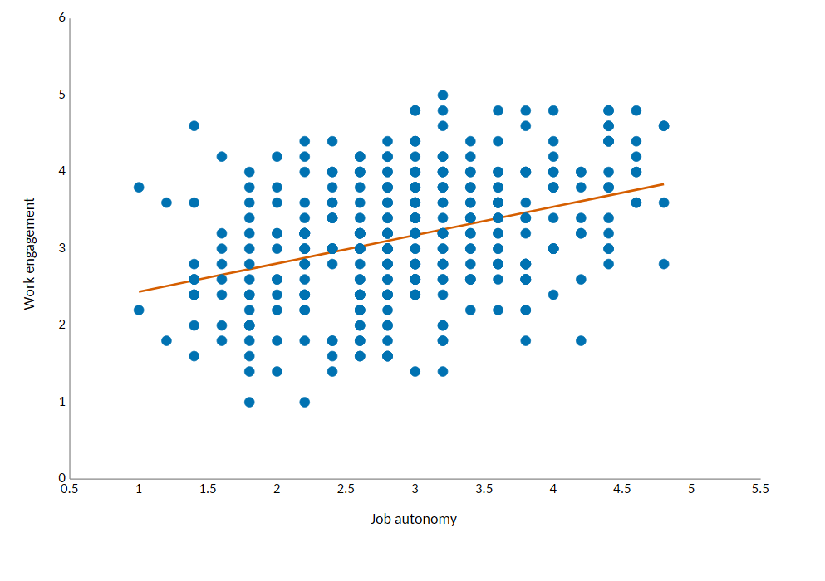

Hypothesis 2
A regression analysis was conducted to evaluate this hypothesis.
The overall regression model was statistically significant, indicating that Supervisor support and Job autonomy, considered together, predict Work engagement better than an intercept-only model. This omnibus result supports H2, though it does not indicate whether each of Supervisor support and Job autonomy individually contributes to the prediction, as those specific contributions are addressed separately.
N = 360, R² = .28, F(2, 357) = 68.72, p < .001, p_adj < .001, adjusted R² = .27
See Table 6.
Table 6
Multiple Regression Predicting Work engagement (N = 360)
Variable | B | SE | β | t | p | 95% CI
(Constant) | 1.10 | 0.18 |  | 6.10 | < .001 | [0.75, 1.45]
Supervisor support | 0.39 | 0.05 | 0.38 | 8.39 | < .001 | [0.30, 0.48]
Job autonomy | 0.30 | 0.05 | 0.30 | 6.53 | < .001 | [0.21, 0.39]
Note. β = standardized coefficient.
The result was: supported.
The hypothesis states that the predictors together predict the outcome, so it was tested by the model as a whole; each predictor's own coefficient shows its unique contribution.
This hypothesis was pre-registered in the confirmatory family of 3 hypotheses, with the Holm (family-wise error rate) correction fixed in the analysis plan before any test was run. The verdict above is based on the corrected p-value (p_adj); the uncorrected p is reported beside it.

Hypothesis 3
An independent-samples t test with Welch's correction was conducted to evaluate this hypothesis.
Consistent with H3, mean Work engagement was statistically significantly higher in the hybrid work arrangement than in the onsite work arrangement, so the independent-group comparison supports the hypothesis that work arrangement is associated with differences in engagement; however, because work arrangement was not randomly assigned, this difference should be interpreted as an observed association rather than evidence that hybrid work causally raises engagement.
N = 360, t(353.17) = 3.05, p = .003, p_adj = .003, g = 0.32, 95% CI [0.11, 0.53] (small effect)
See Table 7.
Table 7
Independent-Samples t Test: Work engagement by Work arrangement
Group | n | M | SD | t(353.17) | p | p_adj
Hybrid | 185 | 3.29 | 0.78 | 3.05 | .003 | .003
Onsite | 175 | 3.03 | 0.83
Note. Welch's t test (equal variances not assumed).
The result was: supported.
This hypothesis was pre-registered in the confirmatory family of 3 hypotheses, with the Holm (family-wise error rate) correction fixed in the analysis plan before any test was run. The verdict above is based on the corrected p-value (p_adj); the uncorrected p is reported beside it.
Figure 2
Work engagement
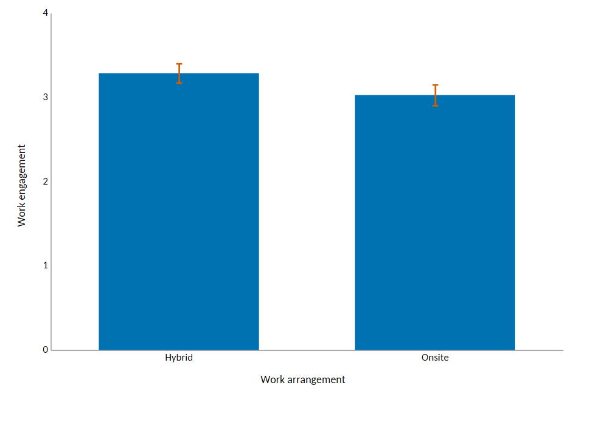
Note. Error bars represent 95% confidence intervals.

Additional Analyses
The analyses in this section are not research hypotheses: they examine background variables that were added to the study's questions, and they are exploratory. Their p-values were corrected together as one exploratory family with the Benjamini-Hochberg (false discovery rate) correction.

Association between Supervisor support, Job autonomy, Work arrangement, Tenure with the employer and Work engagement
An additional exploratory analysis was conducted.
This exploratory extension, adjusting the association of supervisor support and job autonomy with work engagement for work arrangement and tenure group, yielded a fitted model that was statistically significant overall relative to an intercept-only model after correction for multiple comparisons. This indicates that the expanded set of predictors, taken together, accounts for variation in work engagement beyond what would be expected by chance, but it does not by itself establish that the model improves significantly upon the original two-predictor regression, nor does it speak to the significance of the added background predictors individually, the stability of any specific coefficient, or constitute a separate robustness conclusion; such claims would require dedicated model-comparison or coefficient-level tests not reported here.
N = 360, R² = .31, F(5, 354) = 31.29, p < .001, p_adj < .001, adjusted R² = .30
See Table 8.
Table 8
Multiple Regression Predicting Work engagement (N = 360)
Variable | B | SE | β | t | p | 95% CI
(Constant) | 0.92 | 0.19 |  | 4.93 | < .001 | [0.55, 1.29]
Supervisor support | 0.39 | 0.05 | 0.38 | 8.43 | < .001 | [0.30, 0.48]
Job autonomy | 0.30 | 0.05 | 0.30 | 6.68 | < .001 | [0.21, 0.39]
Work arrangement: Hybrid | 0.27 | 0.07 | 0.16 | 3.65 | < .001 | [0.12, 0.41]
Tenure with the employer: Over five years | 0.07 | 0.09 | 0.04 | 0.76 | .447 | [-0.11, 0.26]
Tenure with the employer: Two to five years | 0.06 | 0.08 | 0.03 | 0.67 | .503 | [-0.11, 0.22]
Note. β = standardized coefficient. Work arrangement as a whole: F(1, 354) = 13.29, p < .001. Reference category for Work arrangement: Onsite. Tenure with the employer as a whole: F(2, 354) = 0.35, p = .706. Reference category for Tenure with the employer: Under two years.

Additional Findings
An exploratory factor analysis examined the questionnaire's measurement structure, separately from the research hypotheses.
N = 360
KMO = .90, Bartlett χ²(105) = 2207.42, p < .001
See Table 9.
Table 9
Exploratory Factor Analysis: Factor Loadings
Item | Factor 1 | Factor 2 | Factor 3
I have freedom to choose how to carry out my tasks. | .07 | .68 | -.06
I can decide the order of tasks during my workday. | -.01 | .77 | .01
I have discretion in choosing how to solve a work problem. | .02 | .72 | -.03
I can adapt my work method to the needs of a task. | -.03 | .72 | .10
I can make decisions about my day-to-day work. | .00 | .70 | -.02
My supervisor is available when I need help. | .11 | -.04 | .70
My supervisor gives feedback that helps me in my work. | .06 | -.04 | .71
My supervisor takes the difficulties I raise seriously. | -.03 | .04 | .70
My supervisor supports me in dealing with workload. | -.10 | .04 | .75
I can rely on my supervisor when a professional difficulty arises. | .03 | .00 | .70
I feel energetic while working. | .79 | -.05 | -.01
I find my work tasks interesting. | .71 | .05 | .01
I feel committed to putting effort into my work. | .71 | .09 | .02
I am absorbed in my work while carrying out a task. | .70 | .01 | .01
I feel enthusiastic about my work. | .76 | -.03 | .02
Sum of Squared Loadings | 2.80 | 2.63 | 2.57
Proportion of variance | .19 | .18 | .17
Note. Extraction: minimum residual; rotation: Oblimin. Each item's highest loading is in bold.

